AMAZON SALES ANALYSIS

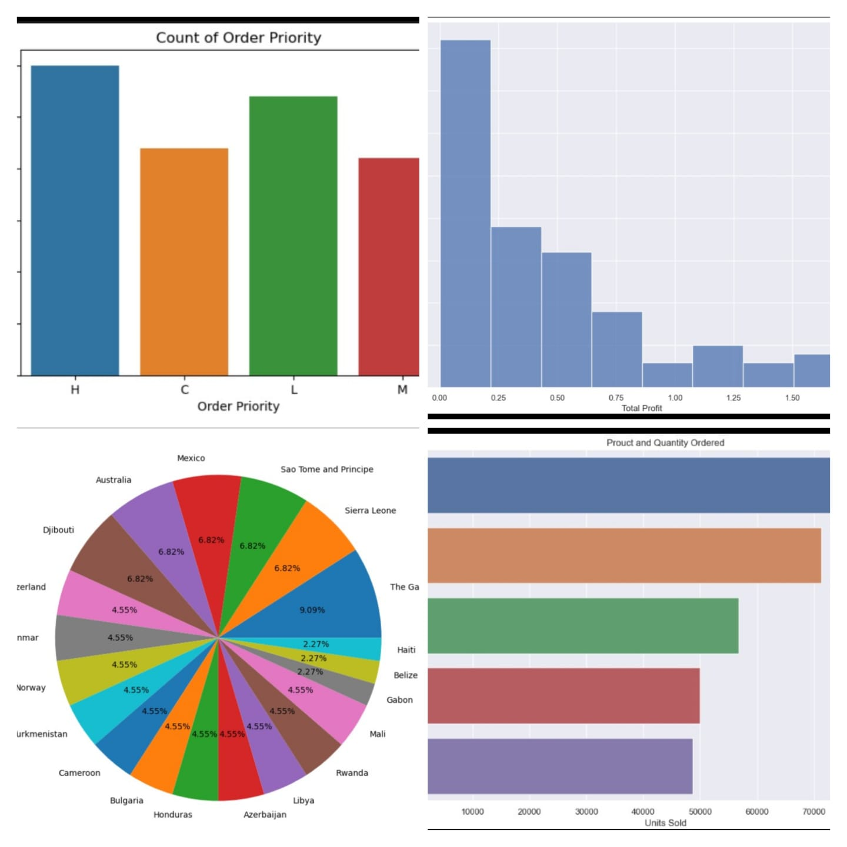

**About this project**

# **Introduction:**

This project focuses on conducting **a comprehensive analysis of Amazon sales data** spanning the years 2010 to 2017. The primary goal is **to uncover trends, patterns, and insights within the vast dataset,** shedding light on the e-commerce giant's sales performance over the specified period.



# Purpose:

E-commerce is not only about movement of goods from one place to the other. But it has many things to say about the **people's behavior like what motivates them, how it changes over time and regions**, etc. I am being personally interested in **human psychology,** found analyzing the e-commerce giant Amazon's sale performance data joyful to understand the marketplace and the customer preferences.

# Data Collection:

The dataset I used for my analysis had provided me by Unified Mentor (a remote internship provider). The **dataset includes** information on **product (item) types, their retail prices, unit sold, unit cost, order and ship dates, geographical information, sales channels** and more. Challenges in **data cleaning, profiling and normalization were addressed using Microsoft Excel and Query Editor on Power BI** to ensure the accuracy of the analysis.

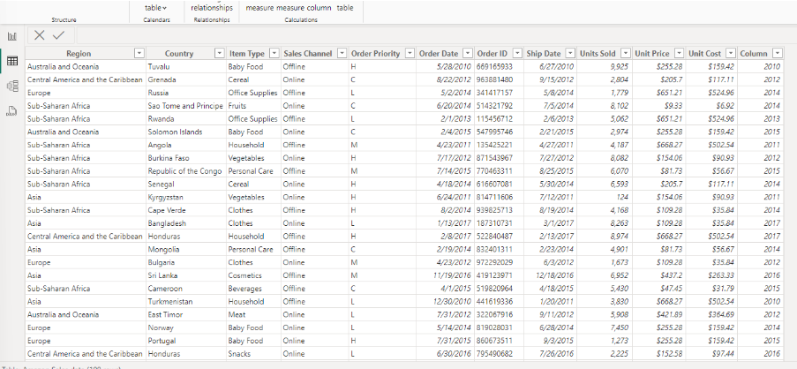

# Methodology:

I began the **Exploratory Data Analysis (EDA)** phase by formulating key questions and answering them based on my understanding of the project:

### What is the objective of this analysis?

The primary goal is to analyze sales, revenue, and identify patterns such as rises or falls. Additionally, the aim is to find strategies **to positively impact sales and profit while reducing overall costs**.

### What are the topline KPIs for the business in the given data?

Key performance indicators (**KPIs**) include **Total Revenue, Total Sell, Cost Reduction, and Profit increas**e over time, analyzed across different geographical locations.

### What could be the determining factors influencing revenue, sales, and overall profit with the available data?

Factors considered include **Customer Location, delivery time, channels of sale** (offline or online), and types of order priority or urgency (Critical, High, Medium, Low).

After collecting these details and addressing related questions, I created essential measures for Power BI data visualization. This includes metrics like Total Sale, Total Revenue, Total Profit, Profit %, and others to support Time-series and Geospatial analysis.

The Time-series analysis involves examining Month-over-Month (MoM) and Year-over-Year (YoY) changes in sales to understand short-term and long-term KPI performance.

Furthermore, an examination of **delivery time (ship date - order date)** was conducted to comprehend its relationship with changes in sales over different regions. Recognizing the significant role of **delivery time as a major contributor to customer satisfaction**, it is anticipated to have a substantial influence on sales

# **Key Findings:**

# In the past 8 years (2010-2017), our sales experienced a significant decline, amounting to approximately $28 million. The reasons for this decline include:



**Limitations and Future Work:**

While in this analysis we tried to provide valuable insights, it is essential to acknowledge **limitations such as the scope of the available dataset and potential biases from my side**. So, my future work could involve **exploring more granular data, incorporating real-time updates and statistical methods** and considering external factors such as economic conditions that may impact Amazon's sales dynamics.

# **Conclusion:**

In this project, I aimed to unveil hidden patterns within Amazon's E-commerce business goals and objectives, by utilizing my newly acquired **skills in Excel and Jupyter Notebook.**

## Additional project images

## 